Working with BioLink Material

Working with BioLink Material 2
How Material information is organised 3
Why Material and not specimens? 3
Sites, Site Visits and Material 3
Sites 3
Details of Site items 4
Site Visits 6
Details of Site Visit items 6
Material 6
Details of Material items 6
Multimedia 9
Accessing and maintaining material information: the Site Explorer 9
The Site Explorer 9
Viewing information: the Contents Tab 9
Adding, editing and deleting items 10
Region properties 10
Site, Site Visit and Material names 10
Changing the placement of Explorer items 11
Locating information: the Find tab 11
Managing commonly used information: the Favorites tab 11
Site Explorer commands 12
Entering Material information 13
Entering information in fields 13
Text fields 13
Phrase fields 13
Linked fields 14
Date fields 14
Auto-Number fields 15
Entering latitude and longitude coordinates 16
Coordinate formats 16
Geocoding sites using eGaz 16
Using eGaz to enter named places 16
Entering Traits and Notes 16
Adding new Traits 17
Adding new Notes 17
Accessing the Rapid Data Entry and Detail windows 17
Opening Detail windows from the Site Explorer 17
Opening Detail windows from the Mapping Assistant 17
Opening Detail windows from the Rapid Data Entry window 17
Opening Detail windows from the Material Detail window 18
Rapid Data Entry 18
Sites, Site Visits and Material in the Rapid Data Entry window 19
Information in the Rapid Data Entry window 19
Site panel information 19
Site Visit panel information 20
Material panel information 20
Material Subpart information 21
Entering additional Detail information 21
Automatically adding information to new records 21
Rapid Data Entry commands 21
File menu 21
Edit menu 21
Site Detail window 22
The General tab 22
The Position tab 23
The Elevation tab 24
The Geology Tab 24
The Multimedia tab 25
The Traits and Notes tabs 26
The Ownership tab 26
Site Details window commands 26
Site Visit Detail window 27
The General tab 27
The Traits and Notes tabs 27
The Ownership tab 27
Site Visit Detail window commands 28
Material Detail window 28
The General tab 28
The Identification tab 29
The Subpart tab 30
The Associates tab 30
The Curation Event tab 31
The Labels tab 32
The Multimedia tab 32
The Traits and Notes tabs 33
The Ownership tab 33
The Summary tab 33
Material Detail window commands 33
Traps 34
Trap Detail window 34
The General tab 34
The Traits and Notes tabs 34
The Ownership tab 34
Trap Detail window commands 35
Automatically adding information to new records 35
Rapid Data Entry’s Copy Current Data command 35
Material Reports 36
Taxa for Sites Report 36
Material for Trap Report 36

Working with BioLink Material

BioLink provides a rich assortment of tools to manage specimen-based information. The primary tool for accessing this information is the Site Explorer. The Site Explorer contains a complete list of all material in a database, organised by regions, collecting localities, collectors and dates. Regions, countries, sites, site visits and material can be retrieved and viewed hierarchically using this Explorer. The Explorer also provides a search facility and a method of organising commonly used information. Data items can be edited directly from the Explorer using the Rapid Data Entry window or the Detail windows. The Rapid Data Entry window is used to enter and update the most commonly used information while the Detail windows provide access to a wide range of additional information about sites, site visits, material and traps/bulk samples. Determining the geographic coordinates of sites (or geocoding) can be quickly and accurately completed using online gazetteers and eGaz. This feature can even be used to determine the coordinates of sites described by a distance and direction from a named place. A GIS facility, the Mapping Assistant, can be used to visually display the geographic location of sites on user-specified, scalable maps. This tool can also be used to show the collection sites for all material held for a given taxon.
A number of predefined reports are provided to quickly and easily access commonly used information. An export facility is also available to transfer data to other programs. Lists of sites where a taxon is known to occur and taxa known from a site can be prepared simply by dragging a taxon name (at any rank) and a region or site (at any scale) onto a form and pressing the Preview button. Lists of material for a taxon can also be produced directly from the Taxon Explorer. Specimen labels, managed as sets, can be prepared and formatted as required.

How Material information is organised

Why Material and not specimens?
BioLink Material manages specimen-based information. In most cases this information comes from specimens held in biological collections. However, BioLink Material can also manage information derived from published literature or observations where specimens were not collected. From a BioLink perspective there is little difference between these sources. All are based on an individual of a species being at a specific location at a given time. The basic information involved is essentially the same (or at least potentially the same) and only the details vary.
BioLink distinguishes among these sources of information using a field called ‘Source’ that is stored with material details. By specifying the source, information based on vouchers (that is, specimens held in a collection) can be separated from information based on literature or observations (where no specimens were collected). This allows the broadest range of information to be collected and managed with the option to filter and select the most appropriate information for any given question.
One of the advantages of managing vouchered and unvouchered information within a single system is the ease of combining these data sets during analysis. For example, with taxonomically well-known groups such as many vertebrates, observation-based data is highly reliable and often easier and less expensive to collect (because of the difficulties in obtaining collecting permits and the time and space required for curation and storage of specimens). Bird and mammal surveys are good examples of this observation-based information. These sources can provide information that would otherwise be unavailable. By managing this information together with voucher-based information the same data quality indicators, maintenance procedures and analytical tools can be applied to both.

Sites, Site Visits and Material
Material information is organised around three main categories: Sites, Site Visits and Material. Sites are geographic locations, the places where collections or observations have been made. They are the spatial or ‘where’ component of information concerning material. Site visits are trips by individuals to sites at specific times or periods. They are the personnel and temporal component, the ‘who’ and ‘when’, information. Material is the specimens collected or observed during site visits. They are the ‘what’ component.
Putting these three components together, a Site can have any number of visits, and each visit can result in any number of specimens being collected or observed. This model conforms well to the collecting practices of many biologists.

Sites
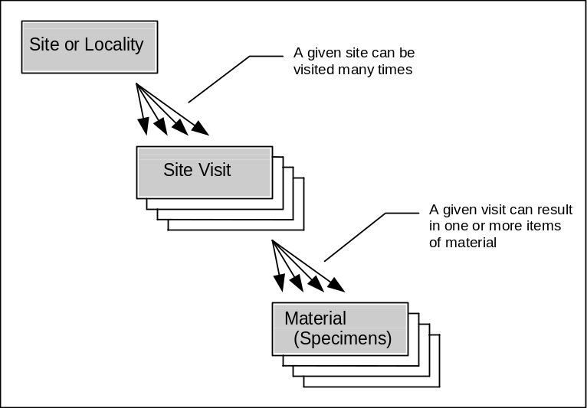Sites are the geographic locations where material is encountered. For each site, BioLink Material stores information describing its location using the political description (usually countries, towns) and coordinates (latitude/longitude, UTM/map grids), and its elevation or depth, geology, multimedia and user-defined Traits and Notes (see below for details of specific items stored). Data is entered using the Rapid Data Entry or Site Detail windows.

Details of Site items
This information describes the location of a site based on named features, politically recognised regions, areas or features, and geographic coordinate systems.
Political description information
Locality: A description of the place of origin of the material. Most commonly this will be a named place or a distance and direction from a named place. This is generally in a form such as ‘Canberra’, ’10 km SE Canberra’ or ‘Wenlock River, 40 km NW Laura’. This information can be stored as a single item or as three separate items, the Nearest Named Place and a Distance and Direction. The second option gives increased flexibility during report generation.
Political Region: The political region in which the Locality is found. This will normally be a country or state/province/territory. The political region must be present in the Site Explorer before it can be associated with a Locality.
Informal Locality: A description based on a non-named place or based on features which are only meaningful in a local context (for example ‘Near the small hill just south of the river crossing’).

Position information
This information describes the location of a site based on geographic coordinates. These coordinates can be either latitude/longitude or Universal Transverse Mercator (UTM or map grids). Also included is information on the source of, or how the coordinates were determined, an estimate of their accuracy and who and when they were determined.
Coordinates: The coordinates of the Locality. These can be either Latitude/Longitude or UTM/map grid references. A single set is required for a Point locality while a pair is required for Bounding Box and Line localities.
Geometry: Point, Bounding Box or Line: A locality can be described or delimited using coordinates which represent a point, rectangle or line. For a point, a single set of coordinates is required while pairs of coordinates are needed for a rectangle (to specify the northwest and southeast corners) and for a line (to specify the end points).
Datum: The datum used when calculating Latitude/Longitude and UTM/map grids.
Map Projection: The projection of the map or GPS used when determining the coordinates.
Map Name: The name of the map used when determining the coordinates.
Version: The version or date of the map used when determining the coordinates.
Source: Where or how the Latitude/Longitude coordinates were determined. This can include sources such as map using label data, gazetteer using label data, GPS, collector, compiler, or on label/sheet.
Original: The original format of the coordinates. This will commonly be Latitude/Longitude, Decimal Degrees, UTM or a similar phrase.
Error: An estimate of the accuracy of the Latitude/Longitude coordinates. This is recorded as an error distance in metres. The lower the value, the more accurate the coordinates are believed to be. As an approximation, 1 second = 25 m, 5 seconds = 100 m, 10 seconds = 200 m, 30 seconds = 1 km, 1 minute = 2 km, 5 minutes = 10 km, 10 minutes = 20 km, 1 degree = 100 km, 5 degrees = 500 km, 10 degrees = 1000 km.
Who: The name of the person determining the coordinates.
Date: The date the coordinates were determined. Pressing the ellipsis button (with the three dots) to the right of the field will open the Calendar window, or today’s date can be entered by pressing Ctrl-D.

Elevation/Depth information
These items relate to the elevation or depth (if aquatic or marine) of the site. Also included is information on its source and who and when it was determined.
Elevation/Depth: Elevation: Selected if this is an elevation.
Elevation/Depth: Depth: Selected if this is a depth.
Upper: If elevation, this is the capture elevation or the upper elevation if part of a range. If a depth, this is the capture depth or the upper depth if part of a range.
Lower: The lower elevation or lower depth.
Depth: The water depth if this is different from capture depth or lower depth (if depth is a range).
Units: The units used for the elevation or depth. This will normally be metres or feet for elevations.
Source: Where or how the elevation or depth was determined. This can include sources such as map using label data, digital elevation model using label data, GPS, altimetre, collector, compiler, field estimate.
Error: An estimate of the accuracy of the elevation value. This is recorded as an error distance in metres or feet. The lower the value, the more accurate the elevation is believed to be.

Geology information
Geologic information is used for fossil-based material.
Era: The geologic era.
Plate: The plate tectonic name.
Stage: The geologic stage.
Lithostratigraphic Formation: The name of the lithostratigraphic formation.
Lithostratigraphic Member: The name of the lithostratigraphic member.
Lithostratigraphic Bed: The name of the lithostratigraphic bed.
Stratigraphic Name: The stratigraphic name.
Stratigraphic Age Bottom: The bottom or lower stratigraphic age.
Stratigraphic Age Top: The top or upper stratigraphic age.
Geology Notes: Notes concerning the geological information.

Multimedia information
Type: The type or class of the multimedia file.
Name: The name of the file.
Caption: A caption for the file as used with this taxon.
In addition, the following information can be stored for each multimedia item in its Properties window:
ID Number: A number assigned to this file.
Artist/Creator: The name of the person who created the file.
Owner: The owner of the file.
Creation Date: The date the file was created.
Copyright: A copyright notice associated with the file.
Traits: User-defined traits for the file.
Keywords: Keywords associated with the file.

User-defined traits and notes

Site Visits
Site Visits are collecting trips or observations at a site. For each visit, BioLink Material stores information on the collector’s name(s) and field number assigned to the material, as well as the time and date of the collection or observation and user-defined Traits and Notes. This information is entered using the Rapid Data Entry or Site Visit Detail windows.

Details of Site Visit items
Collectors: The name(s) of the person(s) collecting the material or making the observation.
Field Number: The number assigned by the collector(s) to all material collected during this visit.
Start Date: Either the date on which the material was collected, or the beginning date if collected over a period of time. Dates can be entered directly or using the Calendar window opened by pressing the ellipsis button (with the three dots) to the right of the field, or today’s date can be entered by pressing Ctrl-D. This can be a complete date (day, month and year) or a partial date (month and year or year alone).
End Date: The ending date of the collecting period, if applicable.
Start Time: The time (hour) of the collection or the beginning time of the collection period.
End Time: The ending time of the collecting period, if applicable.
Casual Date: The non-specific date (such as Spring 1980 or Early 1990) or when only a month (without a year) or day (without a month) are known.
User-defined Traits and Notes.

Material
Material is one of the most complex elements managed by BioLink. Much of this complexity is caused by the highly variable nature of ‘material’ as handled by biologists. For example, while most material records are represented by specimens or vouchers held in a collection, they may be based on observations, literature records, photographs or other indirect or secondary references to organisms. In its simplest form, material consists of a single specimen held in a single collection. At its most complex, material may consist of a series of specimens, some of which have been sent to other museums, some of which has been dissected with individual parts housed at different locations within the collection, and which is associated with additional specimens held in other parts of the collection. This range of complexity is regularly encountered. The major items that are recorded for material and their relationships are as follows. This information is entered using the Rapid Data Entry and Material Detail windows.

Details of Material items
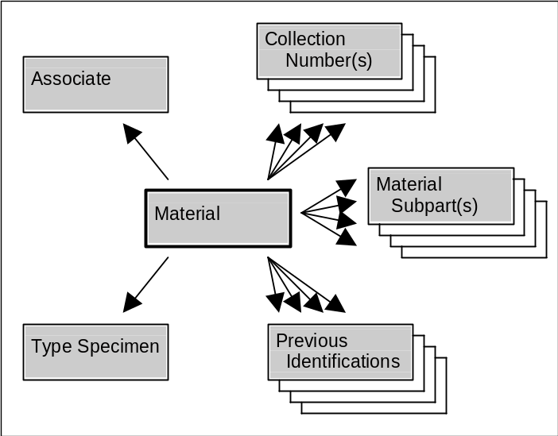Individual specimens often accumulate code numbers as they pass between collector and collection and database. BioLink provides direct support for three such numbers as well as any number of additional numbers stored as Traits.

Specimen identifier information
The three numbers supported by BioLink are defined below. However, these definitions are suggestions only and individual implementations can store alternate types of information in these three fields. The most important point is that the use of these fields should be consistent throughout any given database.
Accession Number: An identification number assigned by the collection for this material. This number will normally be assigned when the specimen is databased and will uniquely identify the material within the collection.
Registration Number: A code previously assigned by the collection owner. This is commonly a registration or similar number assigned using pre-electronic paper-based systems.
Collector Number: A code assigned by the collector, normally at the time of collection.
Source: The source of this material record. This information can be based on a collection (specimen), electronic record (specimen no longer available), literature (published record only), observation (unvouchered sighting), photograph (of existing specimen), or some other source.
Institution: The collection in which the material is held. This is normally a three or four letter abbreviation or acronym, but can be any name up to 100 characters long.

Collecting information
Collection Method: The method used to collect the material (for example pitfall, Malaise trap, reared, cultivated, from wild). (See also Source above.)
Macrohabitat: The macrohabitat where the material was found. This is a general description of the area or habitat and can include vegetation, soil, landform, etc. The person collecting the material or making the observation normally provides this information. These names are entered as text and are not tied to a central list or authority file.
Microhabitat: The microhabitiat where the material was found. This is the specific, small-scale habitat or situation of collection and can include under rock, in rotten wood, flight intercept trap, low vegetation, etc. The person collecting the material or making the observation normally provides this information.
Abundance: The abundance or frequency of the material at the time of collection.
Trap: The name of the trap or bulk sample from which this material was derived. Names of Traps must be present in the Site Explorer before they can be used.

Identification information
Identification: The taxonomic identification of the material. Taxon names must be present in the Site Explorer before they can be used for identification.
Identified By: The name of the person providing the identification or confirming an earlier identification.
Identified On: The date on which the identification was made or confirmed.
Method: The method used to identify the material.
Reference: The publication in which the identification appears (normally used only if the record is based on the published literature, or if the specimen was used during a revision).
Accuracy: An estimate of the likelihood that identification is correct. The following scale is proposed: (0) unchecked by any authority, (1) compared with other named specimens, (2) determined by an authority based on an existing classification or named material, (3) determined by an authority during a taxonomic revision, (4) part of a type series.
Name Qualification: An indication that the cited name is uncertain. Possible entries include cf. (compare with), near (close to), incorrect (current name is incorrect but true name is unknown), aff. (akin to), ? (questionable).
Notes: Assorted notes on the identification.
Identification History: A list of previous identifications of this material. Entries are (optionally) created automatically when the material is reidentified or the classification is changed (for example when creating a synonymy).

Subpart information
Often a single piece of material will consist of a number of components. These components may be parts or fragments of a single specimen or a subset of specimens otherwise considered to represent a single material record (most commonly specimens of the same taxon collected at the same place at the same time). BioLink refers to these components as subparts. The unifying feature of subparts is that they share a site and site visit, and that they are of the same taxon and are given the same databasing (that is, Accession) number. At the same time, each subpart can have its own Registration number and storage location.
Subpart Name: The name of the subpart. This should describe the subpart type, for example wings, genitalia, skin, bark.
Sample Type: The type of the sample or preparation. This includes such things as individual specimen, dissection, subpart name or type, microscope slide, bark sample, sheet or alcohol vial.
Quantity: The number of items in the subpart.
Qualifier: A qualification of the quantity. Possible values include exactly, about, at least, at most.
Gender: The gender or caste of the subpart.
Life Stage: The life stage (for example larvae, immature, adult) or age (for example 20 days, 2 years) of the subpart.
Registration Number: A code assigned to the subpart.
Condition: The condition of the subpart (for example good, damaged, faded).
Storage Location: The location or site where the subpart is stored. This can be a location within the collection or the name of another collection.
Storage Method: Type of storage used for the subpart. This can also indicate the preparation method (for example slide mounted, pin, vial, dried).
Curation Status: The current curation status of the subpart.
Subpart Notes: Assorted notes about the subpart.

Label information
Special Label Text: Special text to appear on printed labels.
Original Label Text: Verbatim text from the label(s) that originally appeared with the specimen(s).

Associate information
An associate is another specimen that is related to this material. The associate will commonly be things such as hosts, prey, parents or children, parasites or predators.
Type: The Associate can be described in one of three ways: by a text-based description, by its taxonomic name as found in the Taxon Explorer, and by its Accession Number as found in the Site Explorer. These three options are described here.
Description: A description of the associate (most commonly its taxon name). This is used if the associate’s taxon is not in the Taxon Explorer and it does not have a Material record in the database.
Taxon: The taxon name of the associate. Names are transferred from the Taxon Explorer using drag and drop or the Select button and can be at any rank. To open the Explorer press the ellipsis button to the right of the Identification field. This is used if there is not a Material record for this associate.
Material: The name of the material record of the associate. This is used when the associate has been recorded in the database. The Material name is transferred from the Site Explorer using drag and drop or the Select button. To open the Explorer press the ellipsis button to the right of the Material field.
Associate is a: The type of relationship between the associate and this specimen (from the perspective of the associate). For example, the associate is the parent of its child (the specimen).
...is its: The type of relationship between the specimen and its associate (from the perspective of the specimen). For example, the material represents the child of its parent (the associate).
Source: The source of this associate information (for example literature, observation, material).
Reference, Page: A link to a reference (and page) if this information is based on the literature.
Uncertain: An indication that this information is uncertain.
Notes: Assorted notes about the associate.

Multimedia
Type: The type or class of the multimedia file.
Name: The name of the file.
Caption: A caption for the file as used with this taxon.
In addition, the following information can be stored for each multimedia item in its Properties window:
ID Number: A number assigned to this file.
Artist/Creator: The name of the person who created the file.
Owner: The owner of the file.
Creation Date: The date the file was created.
Copyright: A copyright notice associated with the file.
Traits: User-defined traits for the file.
Keywords: Keywords associated with the file.
User-defined traits and notes

Accessing and maintaining material information: the Site Explorer
BioLink provides three tools for entering and maintaining material information, the Site Explorer, the Rapid Data Entry window and a set of four Detail windows. These three tools, combined with others such as eGaz, the Mapping Assistant and the Phrase Manager, provide powerful and flexible methods for entering and maintaining high quality and consistent specimen-based data.
The Site Explorer provides an overview of all data in a database organised hierarchically by political or geographic regions. It also provides a search facility and a method to manage and access frequently used information. The Rapid Data Entry window provides access to commonly used information, such as that which is found on most museum-based specimens. This window reduces complexity by hiding less commonly used information yet links to it through the Detail windows. These Detail windows, one for Sites, one for Site Visits and one for Material, provide access to all material information managed by BioLink.
In practice, these tools are used in combination. The Site Explorer is used to inspect existing data and locate specific records. The Rapid Data Entry window is used for initial data entry and for editing individual and sets of records. The Detail windows are called from the Site Explorer or Rapid Data Entry window and are used to examine and enter details about sites, site visits and material.

The Site Explorer
The Site Explorer graphically displays all sites, site visits and material held in a BioLink database. This information is organised hierarchically by regions and countries (and other groupings, if required). Clicking the Material button on the main BioLink toolbar opens the Site Explorer.
As with the Taxon Explorer, the Site Explorer contains three tabs. The first, Contents, shows all information held in the database. The second, Find, allows searches by region name, site group name, site name, trap name, visit name, material name, accession number, or all of the above. The last tab, Favorites, helps organise commonly used information.

Viewing information: the Contents Tab
The Contents tab shows all information held in the database. When initially opened, the Contents tab shows only higher-level regions or groups. To expand these items, click the small plus (+) to the left of the name. This process can be repeated until the full branch is displayed.
The Explorer manages six types of items: Regions, Site Groups, Sites, Traps, Site Visits and Material: each represented by a different icon. Regions represent political areas and are the basic method used to organise sites. Site Groups are used to group sets of regions and sites. They are casual groupings and are not formal political regions. Sites are the localities where material is collected or observed. Site visits are visits to sites at specific times or periods. Site Visits (usually) result in the collection of material.
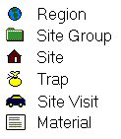
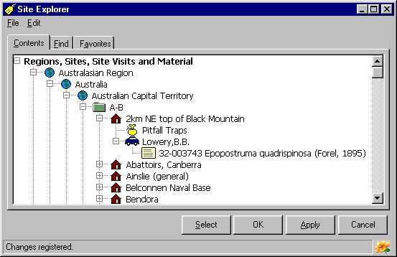
Regions and Site Groups can be nested to any number of levels and terminate with a site or set of sites. For example, Sites can be directly under a Country (under a single Region) or it can be under a County in a State which is in a Country (and thus under three Regions). Site Groups can be added anywhere required above a Site. They are used to group related Regions and/or Sites. In contrast, Sites must be under a Region or Site Group and can only have Site Visits and Traps as direct children. Site Visits can only have Material as children.

Adding, editing and deleting items
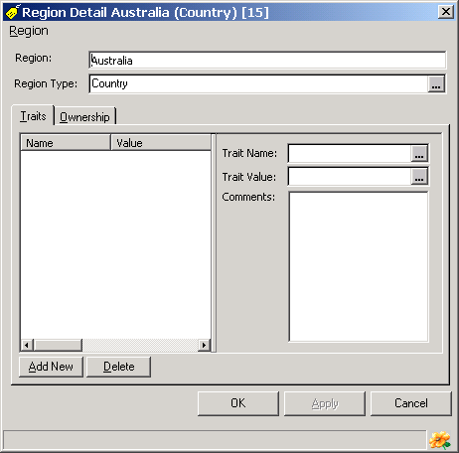
New items are added to the Site Explorer by selecting the item to which the new item will belong (its parent), opening the Edit menu or clicking the right mouse button and selecting the Add command. A menu will open listing the types of new items that can be added. Clicking on the required item type will add a new item to the Explorer with the name ‘<New>’. Replace this text with the proper name of the item being added. To change the name of an existing item, select it and open the Edit menu or click the right mouse button, select the Rename command and enter the new name. Press the Enter key when done. To delete an item (and all of its children), use the same process except select the Delete command. Alternately, select the item and press the Delete key on the keyboard. Any changes made using the Add, Rename and Delete commands will be saved to the database when the Explorer’s OK or Apply buttons are pressed. To abandon changes without saving, press the Cancel button.

Region properties
A range of information can be stored for each Region. This information is accessed by selecting a region, clicking the right mouse button, or opening the Edit menu, and selecting the Edit command. A window will open in which the name of the region and its type can be entered or updated. In addition, traits for the region can entered as required.

Site, Site Visit and Material names
BioLink assigns a name to each site, site visit and material record held in the database. These names are used by the Site Explorer when referring to these items. Names can be created in three ways: directly in the Site Explorer, automatically using the Rapid Data Entry window and manually using the Detail windows. Names can be created directly in the Site Explorer by adding a new site, site visit or material record. These names are added using the Add command as outlined above. When records are entered using the Rapid Data Entry window names are automatically created for each newly added site, site visit and material record. These names are based on information entered in the Rapid Data Entry windows as follows: for sites, the name is based on the locality; for site visits the name is the combination of the collector(s) and initial date of collection, and for material the name is the accession number and identification. Detail windows display the name of the current item in an editable field near the top of the windows. This name can be modified and saved as required.

Changing the placement of Explorer items
Items in the Site Explorer can be reorganised or moved using Drag and Drop. To do this, select the item to be moved, press and hold the left mouse button and drag the item to its new position. The Explorer will ask to confirm the move or will present an error message if an inappropriate move is attempted (such as moving a Material record to a Region). To save changes press the OK or Apply button or to discard them press the Cancel button.

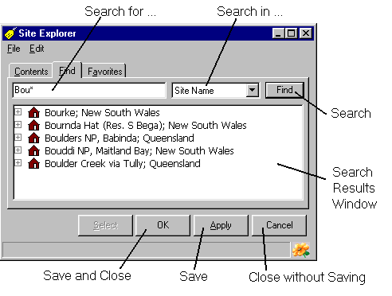
Locating information: the Find tab
The Find tab allows searches by region name, site group name, site name, trap name, visit name, material name, accession number, or all of the above. To locate an item, enter a search term in the upper field, select the type of items to search for in the combo box to its right and press the Find button. Note that the search term can contain wild cards (the * character) anywhere within the string. The retrieved items are displayed with their name followed by a semicolon and the name of their immediate parent. These items can be manipulated in the same hierarchical manner as items in Contents.

Managing commonly used information: the Favorites tab
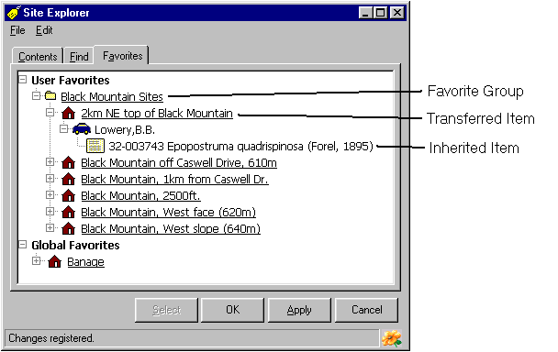
Favorites are a powerful feature that can greatly simplify using the Site Explorer. This is especially important as the size and complexity of a database increases. Copying regularly used information, especially Sites, to Favorites will reduce the need to use Find and will speed access to commonly used records.

Transferring Items to Favorites
Items are transferred to Favorites from Contents and Find. To transfer an item, select it in Contents or Find and open the Edit menu or click the right mouse button. Select the Transfer Item to Favorites command followed by either the User Specific or Global command. The User Specific command will copy the item to the Favorites tab under User Favorites, which is accessible only to the user who created the favorite (that is, the person who was logged on at the time). The Global command will copy the item to Global Favorites where it will be available to all users of the database. Items transferred to Favorites will be underlined in the Explorer while those which were inherited (that is, they are children of a transferred item) will not be underlined.

Organising Favorites using Favorite Groups
While Favorites can simplify access to information, its use can become less efficient as the number of items transferred to Favorites increases. To solve this potential problem, related items can be grouped together in Favorite Groups. A Favorite Group can be thought of as a folder that contains a set of Favorites (and possibly other Favorite Groups).
To create a new Favorites Group, select User Specific Items, Global Items or an existing Favorite Group in Favorites and click the right mouse button or open the Edit menu and select the Add Favorite Group command. Once created, items can be moved to the Group using Drag and Drop. Simply drag an item and drop it onto a new or existing Group. Groups themselves can also be organised in this same way.

Editing Favorites
Note that Favorites are the same as items found in Contents and Find. Any changes made to Favorites, such as adding or deleting taxa or changing relationships, will be saved to the database and will be seen by all users of these items. Thus the same caution should be used when making changes to Favorites as when working with taxa in Contents and Find.

Removing items and groups from Favorites
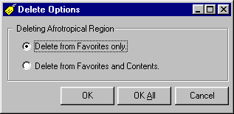
To remove an item from Favorites, select its name and open the Edit menu or click the right mouse button and select the Remove Favorite command. A message will ask to confirm the removal. Note that removing an item from Favorites does not delete it from the database, it only removes it from Favorites and leaves it in Contents. Only items which were transferred directly to Favorites, those that are underlined, can be removed. Children of these Favorites cannot be removed and the Remove Favorite command will not be available if one of these is selected.
To permanently delete an item from Favorites as well as Content (and from the database) select the item, open the Edit menu or click the right mouse button and select the Delete command. A message will ask to confirm the delete. Once deleted, the item will be permanently removed from the database and cannot be retrieved (except from a backup copy of the database).

Site Explorer commands

File Menu
Save/Apply: This command saves any changes made in the Explorer to the database. It is equivalent to pressing the Apply button near the bottom of the Site Explorer. If the Explorer is closed without first saving changes, these changes will be lost.
Close: Selecting the Close command will close the Taxon Explorer window without saving unsaved changes.

Edit Menu
Edit: This command opens the Detail window for the selected item, allowing access to the detailed information for that item. Only a single item can be opened at a time, although any number of items can be opened sequentially. If multiple items have been selected, only the last item selected will be used.
Edit with Rapid Data Entry: This command opens the Rapid Data Entry window filled with information for the selected item(s). If multiple items are selected, or if the selected item contains more than one child (for example, a site with numerous site visits and material records), then information for all items will be presented in this single window.
Add: This command adds items to the Explorer. The types of items that can be added will depend on the type of item selected when this command is called. For example, if a region is selected, only regions, site groups and sites can be added, or if a site is selected only a trap or site visit can be added.
Delete: This command is used to delete the currently selected item from the Explorer. It has the same effect as pressing the Delete key on the keyboard. Deleting an item also deletes all information associated with that item. Deletions will become permanent when the Explorer’s OK or Apply buttons are pressed or the Save/Apply command is selected from the File menu. Deletions can be abandoned by pressing the Cancel button. Once information has been deleted and the change saved to the database, there is no way to recover any of this information—so be careful!
Rename: This command is used to change the name of an item. After selecting this command, the existing name can be modified as required. Pressing the Enter key will save any changes made to the name.
Add Favorite Group: This command adds a Favorite Group to the list on the Favorites tab. These groups can be used to organise items copied to Favorites. This command is only available when the Favorites tab is open.
Add Item to Favorites: This command is used to transfer items from Contents and Find to Favorites. There are two options on a submenu, User Specific and Global, which transfer the selected item to the Favorites of the currently logged on user or to the Favorites available to all users, respectively.
Remove Favorite: This command removes the selected item from Favorites. Only items that where transferred to Favorites, those that are underlined, can be removed.
Create Template: This command, with its submenu, allows creation of site, site visit and material templates. See Automatically Adding Information to New Records for details about templates and their use.
Reports: The Report command opens a submenu containing a list of predefined reports.

Entering Material information
Details concerning material are entered in a series of windows. These windows include the Rapid Data Entry window and four Detail windows. The Rapid Data Entry window is used to quickly enter and edit label-based information as is commonly found on specimens in collections. It is also used when bulk entry of data is needed. The Detail windows allow access to all material information held in a database. They include separate windows for sites, traps, site visits and material.

Entering information in fields
Data entry windows contain five types of fields: text, phrase, linked, date and auto-number. Text fields are used for unique information that is generally not shared with other records. This includes things such as Locality and Registration Number. Phrase fields are used where a limited set of values are commonly used but in some cases other, non-standard values may be required. This is the most commonly used type of field in BioLink and is used for things such as habitat types and Institution names. Linked fields are used when information must be tied to other items in the database or where data must be based on an authoritative list. These include things like taxon names and the names of political regions, among others. Date fields are used to store date-based information. Finally, auto-number fields are used to enter sequential numbers such as Accession and Registration Numbers. Details for using these five types of fields are as follows:

Text fields
Information is entered directly into text fields using the keyboard or cut and paste. This text is not validated or compared with centrally held lists and is not found in picklists. These fields are simple text fields that lack the attached button(s) found in other field types.

Phrase fields
These fields have an ellipsis button (with the three dots) to their right. Clicking this button (or pressing Ctrl+Enter) will open a Phrase window containing a list of suggested or previously used entries for the field. Double clicking on an entry in the Phrase window or clicking the OK button will transfer the selected phrase to the field.
These fields work in a number of ways. Some (for example, Collectors) present a list of previous entries while others (the majority) display phrases entered using the Phrase Manager. In addition, most fields will allow any text to be entered even if it’s not found in the list while a few (Multimedia, Trait and Note Types) require entries to be picked from the list in the Phrase window.

Using the Phrase Manager
The Phrase Manager provides centralised control of the phrases used to fill many of the items within BioLink. This means that controlled vocabularies and authoritative lists can be prepared to increase data consistency and reduce errors when entering data. It also speeds data entry and editing.
To open the Phrase Manager select the Phrases command from the Support Data button on the main BioLink toolbar. The Phrases window contains two lists. The left list contains the names of the BioLink items for which phrases can be assigned and the right list contains the phrases available for the currently selected item.
To add new phrases select an item in the left list of the Phrase Manager followed by the Add Phrase command under Phrases on the Edit menu. This will add a new item to the right list called ‘<New Phrase>‘. Replace this default value with the required one. To delete a phrase, select it followed by the Delete Phrase command under Phrases on the Edit menu. Renaming a phrase is similar but uses the Rename Phrase command. As an option to using the menu system, the mouse pointer can be placed over the right list and the right mouse button clicked. This will open a menu with the New Phrase, Delete Phrase and Rename Phrase commands.

Linked fields
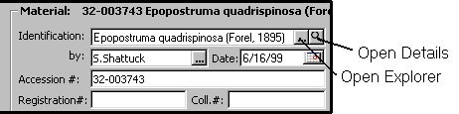
Linked fields are tied to information in an Explorer (Site, Taxon, Region, Location). Only values found in these Explorers will be accepted in these fields. Information can be entered into these fields in two ways. The first is to open the appropriate Explorer, find the required item using Contents, Find or Favorites and either press the Explorer’s Select button or use drag and drop to move the item to the appropriate field. Note that clicking the ellipsis button (with the three dots) can quickly activate the appropriate Explorer to the right of the field. The second way to enter the required information is to type directly in the field and press the Enter key or move the cursor to another field with the tab key or mouse. When the Enter key is pressed or the cursor moves to another field an attempt will be made to find the entered value in the appropriate Explorer. If the entered value is found it will be accepted and data entry will continue as normal. In a few cases the entry may be updated to reflect more complete information (for example, if a species epithet is entered it will be replaced with the full binomen as found in the Taxon Explorer). If, however, the entered value is not found then a message saying ‘No Matches!’ will be displayed and the cursor will return to the field. If the search finds more than one value which matches the entered text then a list of these matches will be presented and the appropriate one can be selected. To see details of the accepted value press the small magnifying glass button to the right of the field. This will open the Detail window for the item.

Entering identifications
Identifications can be as general as ‘Arthropoda’, ‘Aves’ or even ‘Animalia’ or as specific as Iridomyrmex purpureus or Cathartus aura occidentalis. This flexibility is achieved by linking the identification to items in the Taxon Explorer. To enter an identification in the Rapid Data Entry or Material Detail window, open the Taxon Explorer using either the main BioLink toolbar or by pressing the ellipsis button (with the three dots) to the right of the Identification field. Locate the taxon to which the material belongs using Contents, Find or Favorites. Once located, either select the name and press the Explorer’s Select button or drag the taxon name and drop it on the Identification field. Note that the Select button will only be active if the Explorer was activated using the Identification field’s ellipsis button.

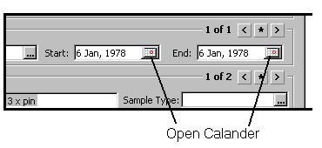
Date fields
Dates are entered throughout BioLink for such things as collecting dates as well as the dates when information has been entered. Dates can be entered directly as text in a variety of formats. These can include all numbers separated by spaces, hyphens, strokes or commas (for example, 1 6 77, 1-6-77, 6/1/77 or 6,1,77) or a combination of numbers and letters representing the months (for example, 1 June 77, 1 Jun 77 or June 1 77). In addition, the date can be selected from a calendar. To open this calendar, press the button to the right of the date field. Clicking the arrows on the sides near the top can change the month displayed by the calendar. The year can be changed by clicking on the year near the middle-top and using the arrow buttons that appear. The current date can be selected by clicking the red circle near the bottom left. Finally, today’s date can be entered without opening the calendar window by placing the cursor in the date field and pressing Ctrl-D.
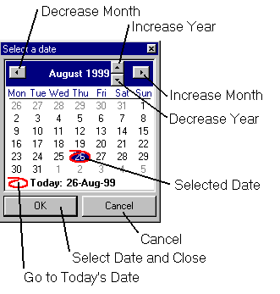
The date will be validated as soon as the enter key is pressed or the cursor is moved to another field with the tab key or the mouse. If the text entered can be interpreted as a valid date then the entry will be changed to the format dd MMM, yyyy, that is the day followed by a three-letter month and a four digit year (for example 1 Jun, 1977). If the text as entered cannot be interpreted as a valid date then it will remain unchanged. If the date is entered as numbers only, the current date format being used by Windows will be checked and used to determine the meaning of the numbers. To determine the current date format, open the Date tab of the Regional Settings control panel. For example, if the Windows format is set to dd MMM yyyy then a date entered as 1 6 77 will be interpreted as 1 Jun, 1977. If, however, the Windows format is set to MMM dd, yyyy then the date 1 6 77 will be interpreted as 6 Jan, 1977. The year will always be converted to four digits. How this is interpreted is set on the Date tab of the Regional Settings control panel. By default, two digit numbers are interpreted as being between the years 1930 and 2029, however this can be changed using the control panel. For example, using the default setting the number 77 would be interpreted as 1977 while 10 would be interpreted as 2010.

Auto-Number fields
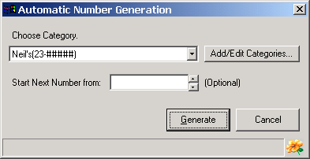
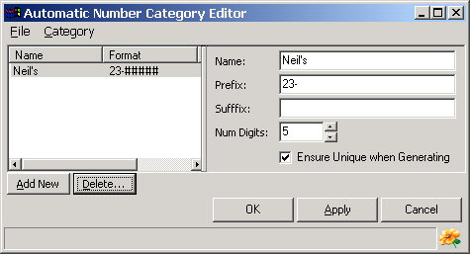
Auto-number fields can accept either plain text entered directly from the keyboard or they can be filled using the Automatic Number Generator. To open the Generator, press the ellipsis button (with the three dots) to the right of the field. The first time this feature is used a new number series must be created. To create this series, press the Add/Edit Categories button. This will open the Category Editor where details for the new series can be specified. Press the Add New button and enter a name for the series, text that is to appear before (Prefix) and after (Suffix) the number and the number of digits required. Also specify if the numbers generated should be unique. Save these changes with the OK or Apply buttons and close this window.
To insert a number in the Rapid Data Entry or a Detail window, select the name of the series in the Category list and press the Generate button. The next number in the series will be returned. To restart a series enter the new starting number in the Start Next Number From box. This will reset the counter to this number. If the Ensure Unique when Generating option has been set, the Generator will search for the highest number used, then generate and insert the next number in the series.

Entering latitude and longitude coordinates
Latitude and longitude coordinates can be entered directly into the Rapid Data Entry or Site Detail windows or they can be transferred from eGaz, the online gazetteer. When entered directly, BioLink will validate entries to ensure latitudes are in the range 0 to 90 degrees and longitudes are between 0 and 180 degrees. If values are entered outside these ranges the cursor will return to the field most recently edited when an attempt is made to leave that field. This will continue until an acceptable value is entered.

Coordinate formats
Coordinates can be entered in any of three formats: degrees, minutes, seconds and direction; degrees and decimal minutes, or decimal degrees. With the latter two formats the direction or hemisphere of the location is indicated as follows: northern latitudes and eastern longitudes are positive while southern latitudes and western longitudes are negative. The format used for the coordinates is selected from the Lat./Long. Format command of the Edit menu. This format can be selected or changed at any time and previous entered coordinates will automatically be converted to the newly selected style.

Geocoding sites using eGaz
eGaz is an online, electronic gazetteer used to determine the latitude and longitude of localities. Localities can be a named place, or a locality a known distance and direction from a named place (for example 10 km NW of Abba River). eGaz can determine the latitude and longitude for both cases. eGaz can also calculate the distance and direction between a locality known only by its latitude/longitude coordinates and a named place. eGaz includes the names of places (towns, cities, mountains, rivers, etc), the political unit to which they belong, their type (populated place, river, mountain, etc) and latitude and longitude. Once found in eGaz, coordinates can be transferred to the Rapid Data Entry and Site Detail windows using the Select button or drag and drop.
Selecting the eGaz command from the Admin & Tool button on the main BioLink toolbar opens the eGaz window. The active gazetteer file can be changed using the Open command on eGaz’s File menu.
To geocode (determine the coordinates for) a site based on a named place, enter the name of the place in the Search field. As the name is entered eGaz will automatically search for the closest match to the information entered. Once located, the latitude/longitude coordinates can be transferred to the Rapid Data Entry or Site Detail windows using the Select button or by dragging the named place row from the main eGaz window and dropping it onto any of the Latitude/Longitude fields. When dropped, a message will be displayed asking if the Locality/Named Place field should also be updated. Clicking No will copy only the coordinate information while selecting Yes will update the Locality/Named Place field from eGaz as well.
To geocode a site a known distance and direction from a named place, first find the named place as outlined above. Then enter the distance in the Distance field, set the units to kilometres or miles and select the direction from a predefined list of 32 compass points in the Direction list box. The coordinates of the site will appear in the field below the Distance/Units/Direction fields. Transferring these coordinates to the Rapid Data Entry or Site Detail windows is accomplished using the Select button or by dragging the offset coordinates from eGaz and dropping them onto the Rapid Data Entry or Site Detail windows as is done for named place-based sites.

Using eGaz to enter named places
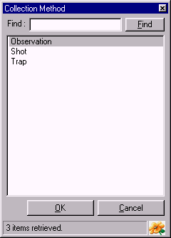
Named places can be typed directly in Locality and Named Place fields or can be entered using eGaz. The advantage of using eGaz is that spelling errors are reduced (since eGaz acts as an authoritative list) and that latitude/longitude coordinates can be automatically entered at the same time. If information is entered in eGaz first it can then be transferred as outlined above.

Entering Traits and Notes
The Rapid Data Entry and Detail windows contain information that is common across most taxonomic groups and scientific disciplines. However, specific taxa and disciplines will need to manage additional information not provided by these windows (and the underlying database). This information includes such things as measurements of specimens, details of storage locations or methods (for example position on microscope slides) or environmental characteristics such as nest sites, soil types or weather conditions. The list of these sorts of data elements is almost limitless.
To address this problem, BioLink allows Traits and Notes to be attached to most items within the database. Traits are characteristics that are best described using a single word, value or short phrase. Notes are text-based, can be of any length and can include font formatting (bold, italics, underlining, font type, size and colour). They are added as required and individual items can have as many as needed. In essence, Traits and Notes allow new fields to be added when and where required.

Adding new Traits
Traits are added to the Detail windows. Open the required window and select the Traits tab. Pressing the Add New button will open a window with a list of previously used Traits. Select an existing Trait or create a new one using the Add New button near the bottom of the list. Press the OK button on the Trait window to create the new Trait and return to the Detail window. The value for this Trait can now be entered in the Trait Value field on the right side of the Traits tab. A comment concerning this Trait can also be included.
To save the new Trait, press the OK or Apply button. To remove a Trait, select the Trait and press the Delete button (once deleted, a Trait cannot be retrieved).

Adding new Notes
Notes are added to Detail windows. Open the required window and select the Notes tab. Pressing the Add New button will open a window with a list of previously used Notes. Select an existing Note or create a new one using the Add New button near the bottom of the list. Press the OK button on the Notes window to create the new Note and return to the Detail window. The text for this Note can now be entered in the right side of the Notes tab. To format text, including bold, italics, underlining, font size and font colour, select the text and use the buttons on the toolbar. Symbols can be entered by pressing the sigma button. The Note text can be printed and copied or cut to the clipboard using the toolbar, and the contents of the Clipboard can be added to a Note using the Paste button.
To save the new Note, press the OK or Apply button. To remove a Note select the Note and press the Delete button (once deleted, a Note cannot be retrieved).

Accessing the Rapid Data Entry and Detail windows
The windows containing material details can be accessed in a number of ways. These include directly from the Site Explorer, Taxon Explorer and Mapping Assistant. In addition, the Detail windows can also be opened from the Rapid Data Entry window and the Site Detail and Site Visit Detail windows can be opened from the Material Detail window.

Opening Detail windows from the Site Explorer
The Detail windows can be opened directly from the Site Explorer. Simply select the item of interest in the Site Explorer, click the right mouse button or open the Edit menu and select the Edit command. The appropriate Detail window will open with information for the selected item. To open the Rapid Data Entry window select the Edit with Rapid Data Entry command rather than the Edit command. This will display the selected item and all of its children.

Opening Detail windows from the Mapping Assistant
The Mapping Assistant is used to visually display the distribution of site-based material information. With a map showing sites displayed, place the mouse pointer over the site of interest and click the right mouse button. Select the Edit Site, Edit Site Visit or Edit Material command from the menu. This will open the appropriate Detail window filled with information for the selected item. If more than one item is present near the mouse pointer a list of these items will be displayed. The required item can then be selected and its details examined in the Detail window.

Opening Detail windows from the Rapid Data Entry window
The Detail windows can be opened directly from the Rapid Data Entry window. To open a window, place the cursor in any field in the Site, Site Visit or Material group of the Rapid Data Entry window and select the Edit Details… command from the Edit menu. The appropriate Detail window will open with information for the current Rapid Data Entry item.

Opening Detail windows from the Material Detail window
The Detail windows for Sites and Site Visits can be opened directly from the Material Detail window. To open these windows, open the Summary tab on the Material Detail window. Information for the Site and Site Visit associated with the Detail window will be displayed. To open the Detail windows for this information, press the Edit Site or Edit Site Visit button on the right of the window. This will open the appropriate Detail window with the information for the selected item.

Rapid Data Entry
The Rapid Data Entry window is used to quickly enter information commonly found on specimens in collections. This information involves sites, site visits and material. It is used when bulk data entry is needed and information can be entered or edited for any number of Sites, Site Visits and Material records.
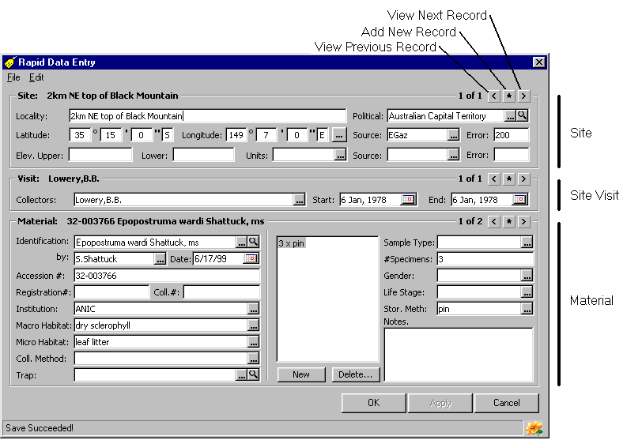The Rapid Data Entry window can be opened in three ways. The first is to click the arrow to the right of the Material button on the main BioLink toolbar and select the Rapid Data Entry command. When opened using this method the Rapid Data Entry window will contain a new, blank record. The second way to open this window is from the Site Explorer. To do this, select a site, site visit or material record in the Site Explorer, click the right mouse button or open the Edit menu and select the Edit with Rapid Data Entry command. The Rapid Data Entry window will open, filled with the selected record(s). Information for all children of the selected item will be included (for example, all visits and material records for a selected site). Finally, the Rapid Data Entry window can be opened from the Taxon Explorer. To open this way, select a taxon (of any rank) and select the Add Specimen command from the Edit menu. The Rapid Data Entry window will open with the Identification field filled with the selected taxon name.

Sites, Site Visits and Material in the Rapid Data Entry window
Information in the Rapid Data Entry window is organised in three panels or sections. The uppermost panel contains information relating to sites, the central panel contains information for site visits and the lower panel contains information about material. The records in these panels are linked to each other so that the material records belong to the current site visit and site visits belong to the current site. The number of sites loaded in the window, along with the number of the site currently displayed, are shown in the upper right corner of the Site panel. To move between these sites use the small arrows to the right of the record numbers or with the cursor in any site item, select the Next and Previous commands from the Edit menu. To add a new site press the Star button between the arrow buttons, select the Site command under Add on the Edit menu, or press Ctrl-T.
The currently displayed Site Visit belongs to the site displayed in the upper panel. The number of site visits associated with this site, along with the number of the current Site Visit, is displayed in the upper right of the panel. Moving between these records and adding new records is accomplished using the small Arrow, Star buttons in the upper right corner of the panel and menu options as is done for sites; the keyboard shortcut key is Ctrl-I. To use the Next and Previous commands to move between visit records, the cursor must be in one of the fields in the Visit panel.
Material belonging to the currently displayed site visit is shown in the lower panel. The numbers, buttons in the upper right corner of this panel, and the menu commands, work the same as those in the middle and upper panels; the shortcut key for adding a new record is Ctrl-M.

Information in the Rapid Data Entry window
The following information can be entered directly in the Rapid Data Entry window:

Site panel information
Site information is entered in the Site section near the top of the window.
Locality: A description of the place of origin of the material. Most commonly this will be a named place or a distance and direction from a named place. This is generally in a form such as ‘Canberra’, ’10 km SE Canberra’ or ‘Wenlock River, 40 km NW Laura’. Names of places can be transferred from eGaz using drag and drop. To open eGaz, press the ellipsis button (with the three dots) to the right of the coordinate windows.
Political: The political region in which the Locality is found. This will normally be a state/province/territory or country. The political region must be present in the Site Explorer. Either enter a region name directly in the field or open the Explorer by pressing the ellipsis button (with the three dots) to the right of the political region field. Locate the region of interest and use either drag and drop or the Explorer’s Select button to transfer the region to the Rapid Data Entry window. To view the properties of a previously entered region, press the magnifying glass button to the right of the field.
Latitude/Longitude: The geographic coordinates of the Locality recorded as latitude and longitude. Coordinates can be entered as Degrees/Minutes/Seconds/Direction, Degrees/Decimal Minutes/Direction or Decimal Degrees. To change format, select the Lat./Long. Format command from the Edit menu. Coordinates can be transferred from eGaz using drag and drop. To open eGaz, press the ellipsis button (with the three dots) to the right of the coordinate windows.
Latitude/Longitude Source: Where or how the Latitude/Longitude coordinates were determined. This can include sources such as map using label data, gazetteer using label data, GPS, collector, compiler, or on label/sheet.
Latitude/Longitude Error: An estimate of the accuracy of the Latitude/Longitude coordinates. This is recorded as an error distance in metres. The lower the value, the more accurate the coordinates are believed to be. As an approximation, 1 second = 25 m, 5 seconds = 100 m, 10 seconds = 200 m, 30 seconds = 1 km, 1 minute = 2 km, 5 minutes = 10 km, 10 minutes = 20 km, 1 degree = 100 km, 5 degrees = 500 km, 10 degrees = 1000 km.
Elevation, Upper: If an elevation, this is the capture elevation or the upper elevation if part of a range. If a depth, the Site Detail window should be used to enter information.
Lower: The lower elevation or lower depth.
Units: The units used for the elevation or depth (generally metres or feet).
Elevation source: Where or how the elevation was determined. This can include sources such as map using label data, digital elevation model using label data, GPS, altimetre, collector, compiler, field estimate.
Elevation error: An estimate of the accuracy of the elevation value. This is recorded as an error distance in metres. The lower the value, the more accurate the elevation is believed to be.

Site Visit panel information
Site Visit information is entered in the Site Visit section near the middle of the window.
Collector(s) name(s): The name(s) of the person(s) collecting the material or making the observation.
Date or Start Date (if a period): Either the date on which the material was collected, or the beginning date if collected over a period of time. This can be a complete date (day, month and year) or a partial date (month and year or year alone). Dates can be entered using the Calendar window opened by pressing the ellipsis button (with the three dots) to the right of the field, or today’s date can be entered by pressing Ctrl-D.
End Date: The ending date of the collecting period.

Material panel information
General Material information is entered in the left side of the Material section near the bottom of the window. Subpart information is entered in the right side of this section.
Identification: The taxonomic identification of the material. Names are transferred from the Taxon Explorer using drag and drop or the Select button and can be at any rank. To open the Explorer, press the ellipsis button (with the three dots) to the right of the Identification field. Alternately, a name can be typed directly into the field. A message will be displayed if the name entered is not found in the database, or if multiple names are found which match that entered. To view details concerning a previously entered name, press the magnifying glass button to the right of the field.
Identified By: The name of the person providing the identification or confirming an earlier identification.
Identification Date: The date on which the identification was made or confirmed.
Accession #: An identification number assigned by the collection for this material. This number will normally uniquely identify the material and will be entered when the material is initially databased. Pressing the ellipsis button (with the three dots) will open the Automatic Number Generator where the next number in a series can be selected if appropriate.
Registration #: A code number previously assigned by the collection owner. This is commonly a registration or similar number assigned when the material originally entered the collection. Pressing the ellipsis button (with the three dots) will open the Automatic Number Generator where the next number in a series can be selected if appropriate.
Collector Number: A code assigned by the collector, normally at the time of collection. Pressing the ellipsis button (with the three dots) will open the Automatic Number Generator where the next number in a series can be selected if appropriate.
Note that the uses of the above code numbers are suggestions only and any information can be stored in these fields. The most important factor when using these fields is to ensure they are used consistently throughout a database.
Institution: The collection in which the material is held. This is normally a three or four letter abbreviation or acronym, but can be any name up to 100 characters long.
Macrohabitat: The macrohabitat where the material was found. This is a general description of the area or habitat and can include vegetation, soil, landform, etc. The person collecting the material or making the observations normally provides this information.
Microhabitat: The microhabitiat where the material was found. This is the specific, small-scale habitat or situation of collection and can include under rock, in rotten wood, flight intercept trap, sweeping low vegetation, etc. The person collecting the material or making the observations normally provides this information.
Collection Method: The method used to collect the material (for example pitfall, Malaise trap, reared, cultivated, from wild).
Trap: The name of the trap or bulk sample from which this material was derived. Names must be present in the Site Explorer. Either enter a name directly in the field or open the Explorer by pressing the ellipsis button (with the three dots) to the right of the Trap field. Locate the Trap of interest and use either drag and drop or the Explorer’s Select button to transfer it to the Rapid Data Entry window. To view details of a previously entered trap, press the magnifying glass button to the right of the field.

Material Subpart information
Subpart information is entered in the right side of the Material section near the bottom of the window. To add new subparts, press the New button. To edit existing subparts, select the required Subpart from the list. To delete a previously entered Subpart, select it in the list and press the Delete button.
Each subpart of a material record has the following information:
Sample Type: The type of this sample (for example individual specimen, dissection, subpart name or type).
# Specimens: The number of specimen(s).
Gender: The gender or caste of the specimen(s).
Life Stage: The life stage (for example larvae, immature, adult) or age (for example 20 days, 2 years) of the subpart.
Storage Method: Type of storage used for the specimen(s) or subpart(s). This can also indicate the preparation method (for example slide mounted, pin, vial, dried).
Notes: Assorted notes about this specimen(s) or part(s).

Entering additional Detail information
In some cases information not found in the Rapid Data Entry window will need to be recorded. In these cases the Detail windows must be used. To activate the Site, Site Visit or Material Detail windows select the appropriate command from the Edit Detail command on the Edit menu. This will open the requested Detail window filled with information for the current record. Each of these windows uses tabs to organise related information. To set the tab that is displayed when the window initially opens use the Default Tab command on the Options menu.
Once the required information has been entered save the changes with the OK button of the Detail window. This will also close the window and return to the Rapid Data Entry window.

Automatically adding information to new records
The Autofill feature of the Rapid Data Entry window allows information to be automatically added to newly created records. To do this, create a new record and enter the information to be repeated in subsequent records. When this information has been entered, select the New Items Copy Current Data command from the Autofill command of the Edit menu. Once activated, all new records created during this session of Rapid Data Entry will contain this information. This information can be edited as required without effecting the information set with the New Items Copy Current Data command. To change the information automatically entered, cancel this command by selecting No Autofill from the Autofill command and then reselect the New Items Copy Current Data command. To turn off the Autofill feature select the No Autofill command.

Rapid Data Entry commands

File menu
Save/Apply: This command saves any changes to the database. It is equivalent to pressing the Apply button. If the window is closed without first saving changes, these changes will be lost.
Close: Selecting the Close command will close the window without saving changes.

Edit menu
Edit Detail: This command, with its submenu, is used to open the Detail windows for Sites, Sites Visits and Material.
Add: This command, together with its submenu, allows the addition of new site, site visit and material records. A new record of the requested type will be added to the Rapid Data Entry window each time this command is called. To save these additions to the database, press the Save or Apply button. To abandon the changes press the Cancel button.
Delete: This command deletes the record in the currently active panel (the panel containing the cursor) and any of its children. When selected, the record (and its children) will be deleted from the Rapid Data Entry window. To delete the record from the database, press the OK or Apply buttons. To abandon the deletion, press the Cancel button.
Next: This command moves to the next record in the selected panel (the panel containing the cursor). This command will only have an effect if there are multiple records in the current panel.
Previous: This command moves to the previous record in the selected panel (the panel containing the cursor). This command will only have an effect if there are multiple records in the current panel.
Auto Fill: This command, together with its submenu, is used to set the Autofill features. The submenu contains the following commands: No Autofill, New Items Copy Current Data, New Items Use Template Data, Set Site Template, Set Site Visit Template, Set Material Template. See Automatically Adding Information to New Records below for additional details.
Lat./Long. Format: This command sets the format used to display latitude/longitude coordinates. Its submenu contains the commands Degrees Minutes Seconds, Decimal Degrees, Degrees - Decimal Minutes. For further details see Entering Latitude and Longitude Coordinates above.
Labels: The Labels menu contains a submenu with the following three commands.
Add Material to Label Set: This command opens a window allowing the current material record to be added to an exiting or new label set.
Copy Common Fields: This command copies commonly used fields to the clipboard. These fields include the locality, political region, latitude, longitude, collectors’ name, start date, end date, accession number, macrohabitat, microhabitat and gender.
Copy All Fields: This command copies all of the Rapid Data Entry fields to the clipboard.

Site Detail window
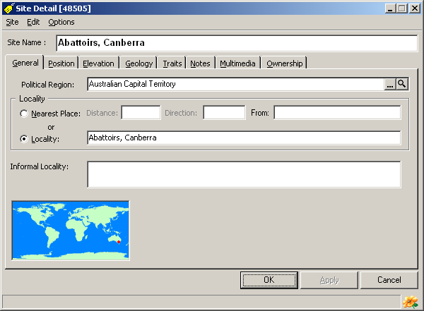
The Site Detail window provides access to information relating to Sites. The window contains several tabs which group related information. These include General, Position, Elevation, Geology, Traits, Notes, Multimedia and Ownership. To set the tab that is displayed when the window initially opens use the Default Tab command on the Options menu. Many fields in this window have ellipsis buttons that open the Phrase Manager and allow direct entry of information from predefined lists. The Political Region field (on the General tab) is filled using the Site Explorer.
The Site Detail window can be opened in three ways: from the Site Explorer, from the Rapid Data Entry window and from the Mapping Assistant (see above for details).

The General tab
This tab contains information on the location of the site described using political regions and named places. Items include the following.
Political Region: The political region in which the Locality is found. This will normally be a state/province/territory or country. The political region must be present in the Site Explorer. Either enter a region name directly in the field or open the Explorer by pressing the ellipsis button (with the three dots) to the right of the political region field. Locate the region of interest and either use drag and drop or the Explorer’s Select button to transfer the region to the Rapid Data Entry window. To view the properties of a previously entered region, press the magnifying glass button to the right of the field.

Locality Information
The locality description can be entered in two ways. The first is as a single description (text string) which contains the complete description, usually composed of a named place and (if applicable) a distance and direction from the named place. This is the most commonly used option. The second way is to enter a named place separately from the distance and direction (if applicable).
To select the method used to store the description, click the Option button in front of either Locality or Nearest Place. The first option provides greater flexibility during data entry because any format can be used for this information. However, the second method provides greater flexibility during reporting as the distance/direction can be placed before or after the named place, as required. When using the Locality option the description of the location is entered in its entirety in the single Locality field. The description can also be transferred from eGaz using drag and drop or its Select button. To open eGaz, press the ellipsis button (with the three dots) to the right of the coordinate windows. When entering locality information using the Nearest Place option, the locality and its offset information (the distance and direction from the place) are stored in separate fields. The advantage of this method is that the format used to present this information can be changed during the generation of reports. For example, labels can be formatted as ‘Canberra, 10 km N’ while a material examined report can use the format ’10 km N Canberra’. This flexibility is not possible if the Locality option is selected. The three fields used with this option are as follows:
- Distance: The distance (with units) from the collection site to the nearest named place (e.g. 10 km).
- Direction: The direction from the collection site to the nearest named place (e.g. SE).
- From: The nearest named place.
Informal Locality: A description based on a non-named place or based on features which are only meaningful in a local context (for example ‘Near the small hill just south of the river crossing’).

The Position tab
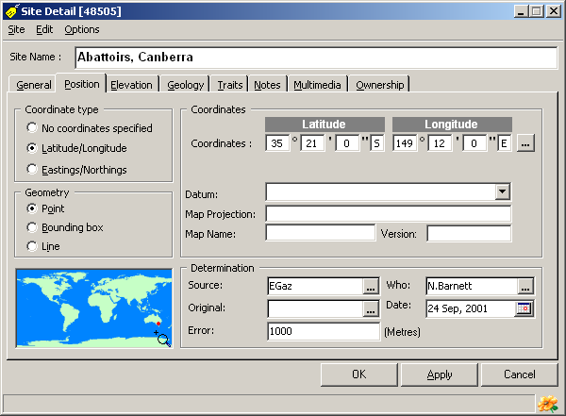
This page contains information on the location of the site described using geographic coordinates (for example, latitude/longitude or UTM). Note that several of the fields have ellipsis buttons (with three dots) which open the Phrase window. This allows direct entry of information from predefined lists.
The mini-map in the lower left corner shows the approximate position of the entered coordinates. While this map cannot be changed, clicking on the small magnifying glass in the map’s lower right corner will open the Mapping Assistant. The Mapping Assistant can then be used to view the location in more detail.
Items on the Position page include the following:
Coordinate Type: No Coordinates Specified, Latitude/Longitude, Eastings/Northings: These options specify the format to be used for entering and displaying geographic coordinates. Selecting these options will change the fields available in the Coordinates panel of the window.
Geometry: Point, Bounding Box, Line: These options specify the geometry of the collection ‘locality’. Point specifies that the locality is a single point, Bounding Box specifies that the locality is a rectangular area and Line specifies that the locality is a line. If Bounding Box or Line are selected a pair of coordinates are required. These specify the top left and bottom right corners of the rectangle or each end of the line.
Coordinates: Latitude/Longitude: The geographic coordinates of the Locality recorded as latitude and longitude. Coordinates can be entered as Degrees/Minutes/Seconds/Direction, Degrees/Decimal Minutes/Direction or Decimal Degrees. To set the required style, select the appropriate format from the Lat./Long. Format command of the Options menu. Coordinates can be transferred from eGaz using drag and drop or its Select button. To open eGaz, press the ellipsis button (with the three dots) to the right of the coordinate fields.
Coordinates: Eastings/Northings: The geographic coordinates of the Locality recorded as UTM or map coordinates.
Datum: The datum used to determine the Latitude/Longitude and UTM/map grids. Datums are selected from a picklist.
Map Projection: The projection of the map used when determining coordinates.
Map Name: The name of the map used when determining coordinates.
Version: The version or date of the map used when determining coordinates.
Source: Where or how the Latitude/Longitude coordinates were determined. This can include sources such as map using label data, gazetteer using label data, GPS, collector, compiler, or on label/sheet.
Original: Original format of the geographic coordinates.
Error: An estimate of the accuracy of the Latitude/Longitude coordinates. This is recorded as an error distance in metres. The lower the value, the more accurate the coordinates are believed to be. As an approximation, 1 second = 25 m, 5 seconds = 100 m, 10 seconds = 200 m, 30 seconds = 1 km, 1 minute = 2 km, 5 minutes = 10 km, 10 minutes = 20 km, 1 degree = 100 km, 5 degrees = 500 km, 10 degrees = 1000 km.
Who: The name of the person determining the coordinates.
Date: The date the coordinates were determined. Pressing the ellipsis button (with the three dots) to the right of the field will open the Calendar window, or today’s date can be entered by pressing Ctrl-D.

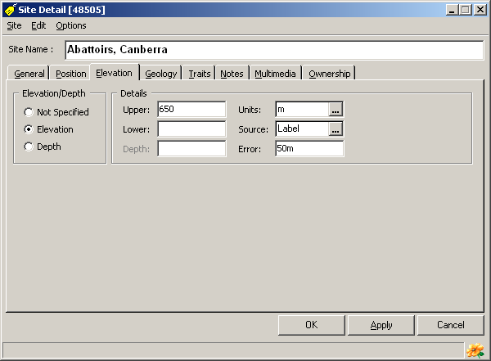
The Elevation tab
These items relate to the elevation or depth (if aquatic or marine) of a locality.
Elevation/Depth: Not Specified, Elevation, Depth: Specifies that the ‘elevation’ is not available, is a (terrestrial) elevation or is a (aquatic or marine) depth.
Upper: If elevation, this is the capture elevation or the upper elevation if part of a range. If a depth, this is the capture depth or the upper depth if part of a range.
Lower: The lower elevation or lower depth of a range.
Depth: The water column depth if this is different from capture depth or lower depth (if depth is a range).
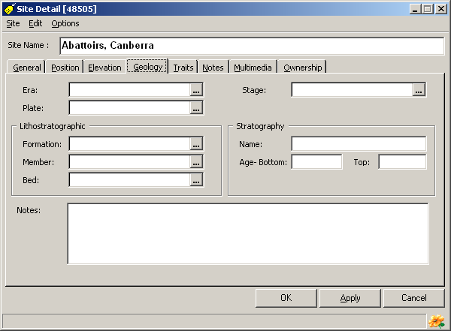
Units: The units used for the elevation or depth.
Source: Where or how the elevation or depth was determined. This can include sources such as map using label data, digital elevation model using label data, GPS, altimeter, collector, compiler, field estimate.
Error: An estimate of the accuracy of the elevation. This is recorded as an error distance in metres. The lower the value, the more accurate the elevation is believed to be.

The Geology Tab
Geologic information for the locality. This will be used for fossil-based sites.
Era: The geologic era.
Plate: The plate tectonic name.
Stage: The geologic stage.
Lithostratigraphic Formation: The lithostratigraphic formation.
Lithostratigraphic Member: The lithostratigraphic member.
Lithostratigraphic Bed: The lithostratigraphic bed.
Stratigraphic Name: The stratigraphic name.
Stratigraphic Age Bottom: The bottom or lower stratigraphic age.
Stratigraphic Age Top: The top or upper stratigraphic age.
Notes: Notes concerning the geological information.

The Multimedia tab
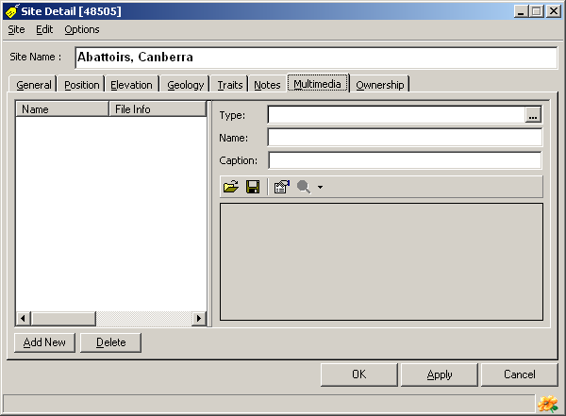
It is often necessary to associate electronically stored or file-based information with a site. BioLink terms this electronic (or digital) information ‘multimedia’. Multimedia can consist of image, sound or video files as well as text documents, spreadsheets or even databases. Any number of multimedia files can be stored for a site. In addition to the actual file, its type, name and caption can also be stored. These files are stored within the BioLink database rather than as links to local files found outside of BioLink. This ensures that this information is always present and reduces the chance of accidental deletion.
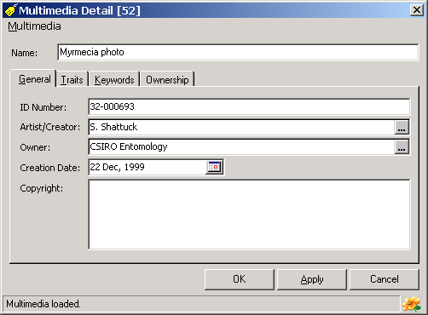
To add a new multimedia file, press the Add New button near the lower left corner of the window. This will create a new entry in the list on the left side of the window and open a File Open dialog box. Locate the file to be added and press OK. This will add the file to BioLink. Alternately, a file can be moved from the Windows Explorer or My Computer using Drag and Drop. Locate the desired file in the Windows Explorer or using My Computer and drag it onto either the Multimedia list or the preview window (on the lower right of the Multimedia window). Details for the file can be entered in the fields on the right side of the window. To edit information for a previously entered file, select it in the list and edit its details on the right. To delete a file select it and press the Delete button. Once changes have been made, press the OK button to save changes and close the Taxon Details window or the Apply button to save changes and leave the window open. Pressing the Cancel button will close the window without saving changes.
The Preview window, on the lower right of the window, will display a preview of most graphics files. If the selected file cannot be viewed, a message will be displayed. To view these non-displayable files, press the magnifying glass button on the toolbar. This will open the application associated with the file and automatically load the file. If no application is associated with the selected file a dialog will open asking the name of the application to use to view the file.
To replace an existing file with a new one, select the old file in the list and press the first toolbar button (the button with the file folder icon). A File Open dialog box will be displayed allowing selection of the replacement file. To save an existing file to disk, select it in the list and press the second toolbar button (the button with a disk icon). A Save As dialog box will open where a new file name and path can be entered. To view properties of a given file press the third toolbar button (with the properties icon). This will open a window where details on an identification number, artist/creator, owner, creation date, copyright, traits and keywords can be entered.
The following items concerning multimedia can be stored:
Type: The type or class of the multimedia file.
Name: The name of the file.
Caption: A caption for the file as used with this taxon.
The following information can be stored for each multimedia item in the Properties window:
ID Number: A number assigned to this file.
Artist/Creator: The name of the person who created the file.
Owner: The owner of the file.
Creation Date: The date the file was created.
Copyright: A copyright notice associated with the file.
Traits: User-defined traits for the file.
Keywords: Keywords associated with the file.

The Traits and Notes tabs
For information on notes and traits see Entering Traits and Notes above.

The Ownership tab
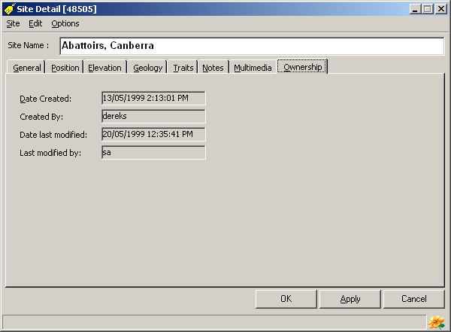
This tab contains information on the person who created the current record as well as the person who most recently modified it. This information is read-only and is maintained by BioLink. The following information is included:
Date Created: The date and time the current record was originally created.
Created By: The logon name of the person creating the record.
Date last modified: The date and time the record was last updated.
Last modified by: The logon name of the person last updating the record.

Site Details window commands

Site Menu
Save/Apply: This command saves changes made in the Detail window. It is equivalent to pressing the Apply button near the bottom of the window. If the window is closed without first saving changes, changes will be lost.
Close: This command will close the window without saving unsaved changes.

Edit menu
Add to Label Set: This command opens a window allowing the current material record to be added to an exiting or new label set.

Options Menu
Lat/Long format: This command controls the format used to display the latitude/longitude coordinates. Its submenu contains the commands Degrees Minutes Seconds, Decimal Degrees, Degrees - Decimal Minutes.
Mini Map: This command is used to change the symbol used on the mini-map on the General and Position pages. Its submenu contains two options, Indicate position by Lines and Indicate position by Dot. As the names suggest, selecting these options switches the position indicators between a pair of vertical and horizontal lines and a small red dot.
Default Tab: This command, with its submenu, sets the tab which is displayed when the Site Details window initially opens. The tab that will be displayed has a check mark before it.

Site Visit Detail window
The Site Visit Detail window provides access to information relating to Site Visits. The window contains several tabs which group related information. To set the tab that is displayed when the window initially opens use the Default Tab command on the Options menu. A pop-up calendar can be used to fill the Date fields. Pressing the button to the right of each date field activates this calendar. These fields can have today’s date entered by placing the cursor in the field and pressing Ctrl-D.
The Site Visit Detail window can be opened in three ways: from the Site Explorer, from the rapid Data Entry window and from the Mapping Assistant (see above for details).
The following information is found in this window:

The General tab
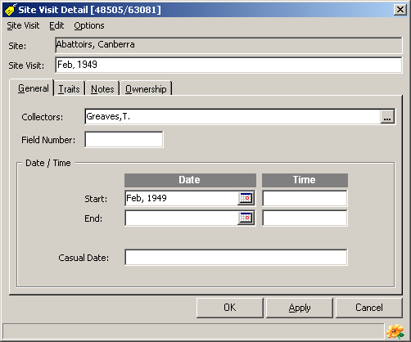
This tab contains information on the collector and the date of the visit. This includes the following information.
Collectors: The name(s) of the person(s) collecting the material or making the observation.
Field Number: The number assigned by the collector(s) to this material, generally when collected.
Start Date: Either the date on which the material was collected, or the beginning date if collected over a period of time. Dates can be entered using the Calendar window that is opened by pressing the ellipsis button (with the three dots) to the right of the field, or today’s date can be entered by pressing Ctrl-D. See Data Fields under Entering Information in Fields above for details of using this window.
End Date: The ending date of the collecting period.
Start Time: The time (hour) of the collection or the beginning time of a collection period.
End Time: The ending time of a collecting period.
Casual Date: A non-specific date (such as Spring 1980 or Early 1990.)

The Traits and Notes tabs
For information on notes and traits see Entering Traits and Notes above.

The Ownership tab
This tab contains information on the person who created the current record as well as the person who most recently modified it. This information is read-only and is maintained by BioLink. The following information is included:
Date Created: The date and time the current record was originally created.
Created By: The logon name of the person creating the record.
Date last modified: The date and time the record was last updated.
Last modified by: The logon name of the person last updating the record.

Site Visit Detail window commands

Site Visit menu
Save/Apply: This command saves changes made in the Detail window. It is equivalent to pressing the Apply button near the bottom of the window. If the window is closed without first saving changes, changes will be lost.
Close: This command will close the window without saving changes.

Edit menu
Add to Label Set: This command opens a window allowing the current material record to be added to an exiting or new label set.
Options menu
Default Tab: This command, with its submenu, sets the tab which is displayed when the Site Visit Details window initially opens. The tab that will be displayed has a check mark before it.

Material Detail window
The Material Detail window provides access to information relating to Material. The window contains several tabs which group related information. To set the tab that is displayed when the window initially opens use the Default Tab command on the Options menu. Many fields have ellipsis buttons that open the Phrase window or Automatic Number Generator. The Identification field (on the Identification tab) is filled using the Taxon Explorer.
The Material Detail windows can be opened in three ways: from the Site Explorer, from the Rapid Data Entry window and from the Mapping Assistant (see above for details).

The General tab
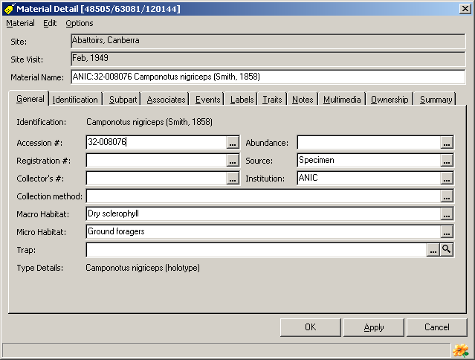
Accession #: An identification number assigned by the collection for this material. This number will normally uniquely identify the material and will be entered when the material is initially databased. Pressing the ellipsis button (with the three dots) will open the Automatic Number Generator where the next number in a series can be selected if appropriate. See Auto-Number Fields under Entering Information in Fields above for details of using this window.
Registration #: A code number previously assigned by the collection owner. This is commonly a registration or similar number assigned when the material originally entered the collection. Pressing the ellipsis button (with the three dots) will open the Automatic Number Generator where the next number in a series can be selected if appropriate. See Auto-Number Fields under Entering Information in Fields above for details of using this window.
Collector Number: A code assigned by the collector, normally at the time of collection. Pressing the ellipsis button (with the three dots) will open the Automatic Number Generator where the next number in a series can be selected if appropriate. See Auto-Number Fields under Entering Information in Fields above for details of using this window.
Note that the uses of the above code numbers are suggestions only and any information can be stored in these fields. The most important factor when using these fields is to ensure they are used consistently throughout a database.
Collection Method: The method used to collect the material or the origin of the sample (for example pitfall, Malaise trap, reared, cultivated, from wild).
Macrohabitat: The macrohabitat where the material was found. This is a general description of the habitat and can include vegetation, soil, landform, etc.
Microhabitat: The microhabitiat where the material was found. This is the specific, small-scale habitat or situation of collection and can include under rock, in rotten wood, flight intercept trap, low vegetation, etc.
Trap: The name of the trap or bulk sample from which this material was derived. Names must be present in the Site Explorer. Either enter a name directly in the field or open the Explorer by pressing the ellipsis button (with the three dots) to the right of the Trap field. Locate the Trap of interest and use either drag and drop or the Explorer’s Select button to transfer it to the Rapid Data Entry window. To view details of a previously entered trap, press the magnifying glass button to the right of the field.
Type Details: A summary of the type status of this material. This information is read-only in this window. To edit this information open the Taxon Explorer, locate the available name to which this material belongs and edit its details.
Abundance: The abundance or frequency of the material at the time of collection.
Source: The source of this material record. This information can be based on a collection (specimen), electronic record (specimen no longer available), literature (published record only), observation (unvouchered sighting), photograph, or some other source.
Institution: The collection/herbarium/museum/institution in which the material is held. This is normally a 3 or 4 letter abbreviation or acronym, but can be any name up to 100 characters long.

The Identification tab
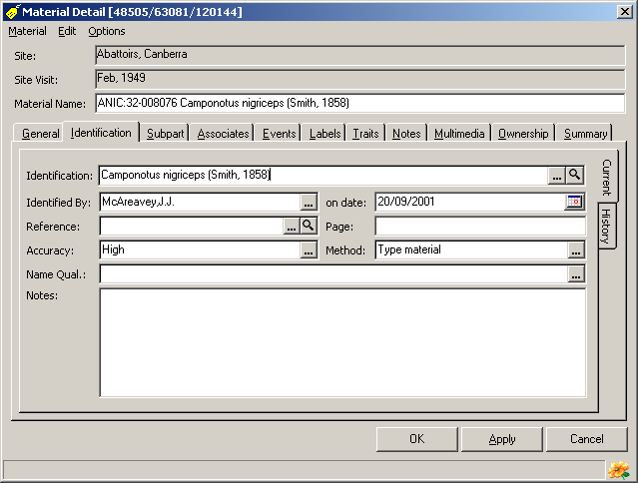
Information on this tab is organised into two sections, one for the current identification and one for previous identifications. To switch between this information click the appropriate tab (Current or History) along the right margin of the window.

Current identification information
Identification: The taxonomic identification of the material. Names are transferred from the Taxon Explorer using drag and drop or the Select button and can be at any rank. To open the Explorer press the ellipsis button (with the three dots) to the right of the Identification field. Alternately a name can be typed directly into the field. A message will be displayed if the name entered is not found in the database, or if multiple names are found which match that entered. To view details concerning a previously entered name, press the magnifying glass button to the right of the field.
Identified By: The name of the person providing the identification.
Identified On: The date on which the identification was made.
Reference and Page: The publication and page in which this identification appears.
Accuracy: An estimate of the likelihood that identification is correct. The following scale is proposed: (0) unchecked by any authority, (1) compared with other named specimens, (2) determined by authority based on existing classification or named material, (3) determined by authority during revision, (4) part of type series.
Method: The method used to identify the material. This can be used as an indication of the quality or reliability of the identification.
Name Qualification: An indication that the cited name is uncertain. Possible entries include cf. (compare with), near, incorrect (current name is incorrect but true name is unknown), ? (questionable).
Notes: Assorted notes on this identification.

Identification history information
A list of previous identifications of this material is found on the History tab. All information from the current identification is (optionally) transferred here when the material is reidentified or the classification is changed (for example when creating a synonymy). To add a previous identification, press the Add New button and enter information on the right of the window. To edit the information for a previous identification, select the identification in the list and edit its details. To delete a previous identification record, select it in the list and press the Delete button.

The Subpart tab
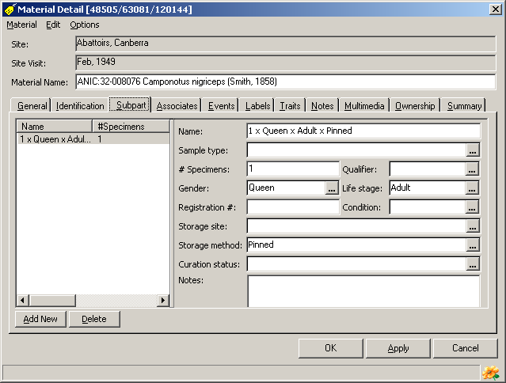
BioLink supports any number of subparts for a given material record. To add new subparts, press the Add New button near the bottom left of the window and enter the subpart’s name and any additional information on the right. To delete an existing subpart, select it in the list on the left and press the Delete button.
The information about subparts is as follows:
Name: The name of the subpart. This should describe the subpart type, for example wings, genitalia, skin, bark.
Sample Type: The type of this sample (for example individual specimen, dissection, subpart name or type).
# Specimens: The number of specimen(s) or part(s).
Qualifier: A qualification of the quantity. Possible values include exactly, about, at least, at most.
Gender: The gender or caste of the specimen(s).
Life Stage: The life stage (for example larvae, immature, adult) or age (for example 20 days, 2 years) of the specimen(s).
Registration #: A collection assigned number for this specimen(s).
Condition: The condition of the specimen(s) (for example good, damaged, faded).
Storage Site: The location or site where the specimen(s) or part(s) is stored. This can be a location within the collection or the name of another collection.
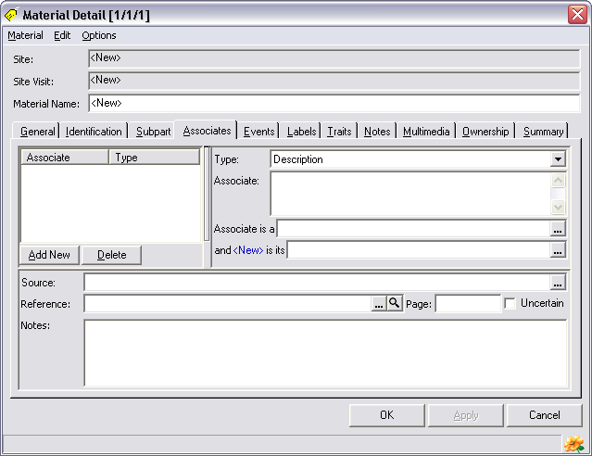
Storage Method: Type of storage used for the specimen(s) or part(s). This can also indicate the preparation method (for example slide mounted, pin, vial, dried).
Curation Status: The current curation status of this specimen(s) or part(s).
Notes: Assorted notes about this specimen(s) or part(s).

The Associates tab
BioLink supports any number of associates for a given material record. To add a new associate, press the Add New button near the bottom left of the window. Enter the associate’s details on the right. To delete an existing associate, select it in the list on the left and press the Delete button.
The information about associates is as follows:
Type: The Associate can be described in one of three ways: by a text-based description, by its taxonomic name as found in the Taxon Explorer, and by its Accession Number as found in the Site Explorer. These three options are described here.
Description: A description of the associate (most commonly its taxon name). This is used if the associate’s taxon is not in the Taxon Explorer and it does not have a Material record in the database.
Taxon: The taxon name of the associate. Names are transferred from the Taxon Explorer using drag and drop or the Select button and can be at any rank. To open the Explorer press the ellipsis button to the right of the Identification field. This is used if there is not a Material record for this associate.
Material: The name of the material record of the associate. This is used when the associate has been recorded in the database. The Material name is transferred from the Site Explorer using drag and drop or the Select button. To open the Explorer press the ellipsis button to the right of the Material field.
Associate is a: The type of relationship between the associate and this specimen (from the perspective of the associate). For example, the associate is the parent of its child (the specimen).
...is its: The type of relationship between the specimen and its associate (from the perspective of the specimen). For example, the material represents the child of its parent (the associate).
Source: The source of this associate information (for example literature, observation, material).
Reference, Page: A link to a reference (and page) if this information is based on the literature.
Uncertain: An indication that this information is uncertain.
Notes: Assorted notes about the associate.

The Curation Event tab
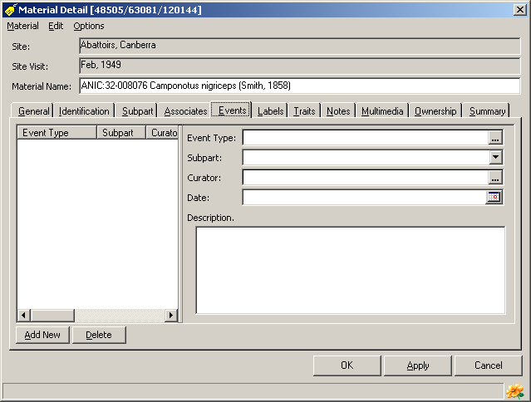
A piece of material can have any number of curation events. To add a new event press the Add New button near the bottom left of the window. Its details can then be entered in the fields on the right of the window. To edit an existing event, select the event from the list and edit its details on the right. To delete a previously entered event, select it in the list and press the Delete button.
The information concerning curation events is as follows:
Event Type: The type of this curation event.
Subpart: The subpart (if any) which was curated.
Curator: The name of the curator undertaking this action.
Date: The date of the event.
Description: A description of or notes on the curation event.

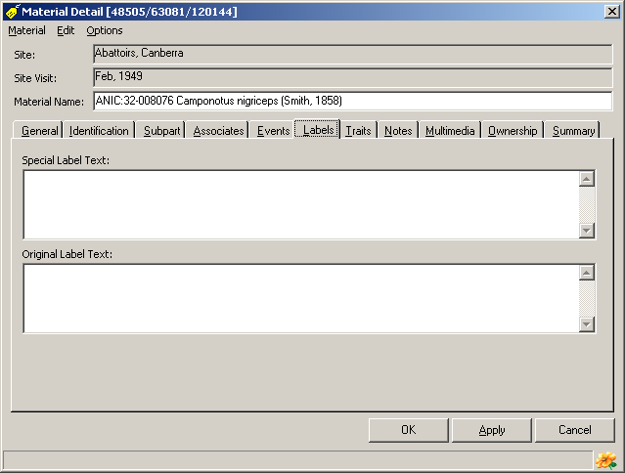
The Labels tab
Special Label Text: Special text to appear on printed labels.
Original Label Text: Verbatim text from the label(s) that originally appeared with the specimen(s).

The Multimedia tab
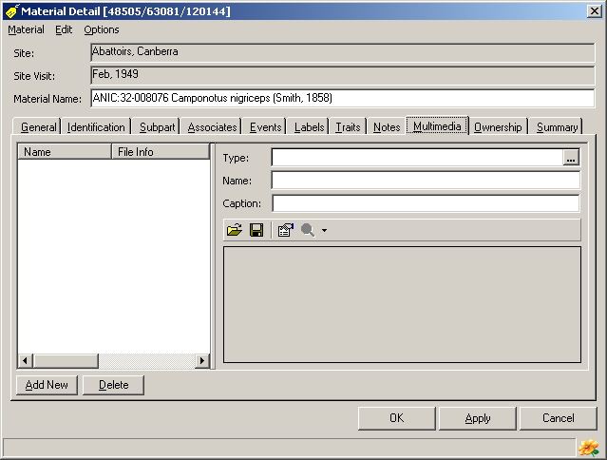
It is often necessary to associate electronically stored or file-based information with material. BioLink terms this electronic (or digital) information ‘multimedia’. Multimedia can consist of image, sound or video files as well as text documents, spreadsheets or even databases. Any number of multimedia files can be stored with a material record. In addition to the actual file, its type, name and caption can also be stored. These files are stored within the BioLink database rather than as links to local files found outside of BioLink. This ensures that this information is always present and reduces the chance of accidental deletion.
To add a new multimedia file, press the Add New button near the lower left corner of the window. This will create a new entry in the list on the left side of the window and open a File Open dialog box. Locate the file to be added and press OK. This will add the file to BioLink. Alternately, a file can be moved from the Windows Explorer or My Computer using Drag and Drop. Locate the desired file in the Windows Explorer or using My Computer and drag it onto either the Multimedia list or the preview window (on the lower right of the Multimedia window). Details for the file can be entered in the fields on the right side of the window. To edit information for a previously entered file, select it in the list and edit its details on the right. To delete a file, select it and press the Delete button. Once changes have been made press the OK button to save changes and close the Taxon Details window or the Apply button to save changes and leave the window open. Pressing the Cancel button will close the window without saving changes.
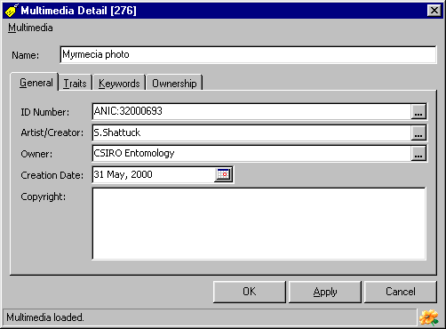
The Preview window, on the lower right of the window, will display a preview of most graphics files. If the selected file cannot be viewed a message will be displayed. To view these non-displayable files press the magnifying glass button on the toolbar. This will open the application associated with the file and automatically load the file. If no application is associated with the selected file a dialog will open asking the name of the application to use to view the file.
To replace an existing file with a new one select the old file in the list and press the first toolbar button (the button with the file folder icon). A File Open dialog box will be displayed allowing selection of the replacement file. To save an existing file to disk, select it in the list and press the second toolbar button (the button with a disk icon). A Save As dialog box will open where a new file name and path can be entered. To view properties of a given file press the third toolbar button (with the properties icon). This will open a window where details on an identification number, artist/creator, owner, creation date, copyright, traits and keywords can be entered.
The following items concerning multimedia can be stored:
Type: The type or class of the multimedia file.
Name: The name of the file.
Caption: A caption for the file as used with this taxon.
The following information can be stored for each multimedia item in the Properties window:
ID Number: A number assigned to this file.
Artist/Creator: The name of the person who created the file.
Owner: The owner of the file.
Creation Date: The date the file was created.
Copyright: A copyright notice associated with the file.
Traits: User-defined traits for the file.
Keywords: Keywords associated with the file.

The Traits and Notes tabs
For information on notes and traits see Entering Traits and Notes above.

The Ownership tab
This page contains information on the person who created the current record as well as the person who most recently modified it. This information is read-only and is maintained by BioLink. The following information is included:
Date Created: The date and time the current record was originally created.
Created By: The logon name of the person creating the record.
Date last modified: The date and time the record was last updated.
Last modified by: The logon name of the person last updating the record.

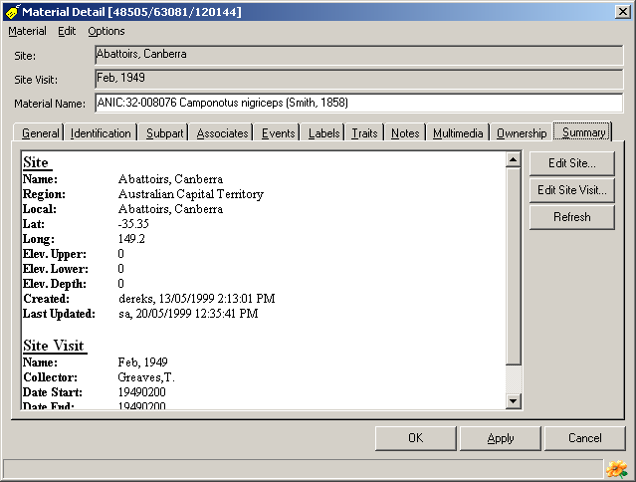
The Summary tab
This tab reports a summary of the site and site visit details for the material record. Only fields which have information entered are displayed; fields which are blank are not listed. This allows these details to be examined without opening the Site Detail and/or Site Visit Detail windows.
To update or change information displayed on this page press the Edit Site or Edit Site Visit button to open the appropriate Detail window. Information can then be modified as required and saved. After making changes and returning to the Material Detail window, press the Refresh button to update the main window to reflect any changes made during editing.

Material Detail window commands

Material Menu
Save/Apply: This command saves any changes made in the Detail window to the database. It is equivalent to pressing the Apply button near the bottom of the window. If the window is closed without first saving changes, these changes will be lost.
Close: Selecting the Close command will close the window without saving unsaved changes.

Edit menu
Add to Label Set: This command opens a window allowing the current material record to be added to an exiting or new label set.
Options Menu
Default Tab: This command, with its submenu, sets the tab which is displayed when the Material Details window initially opens. The tab that will be displayed has a check mark before it.

Traps
Traps are used to associate individual material items. While the term ‘trap’ has been used, this mechanism applies equally well to bulk samples, ‘lots’ and similar sets of material which are collected at the same place and time. The main difference between a ‘trap’ and a ‘lot’ is that a trap can be revisited any number of times and the material for each visit tracked, while a ‘lot’ is generally regarded as a single collection event (occurring at a single point in time or time period). By using the trap as the model, BioLink offers greater flexibility when managing sets of material items.
Traps are added to the Site Explorer under a Site. See Accessing and Maintaining Information: The Site Explorer for details on adding Traps to this Explorer.
Material is associated with a Trap using the Rapid Data Entry and Material Detail windows. Enter the name of the Trap in the Trap field of these windows, or click the ellipsis button (with the three dots) to the right of the field and select the Trap from the Site Explorer. To view details of the selected trap, press the magnifying glass button to the right of the Trap field.

Trap Detail window
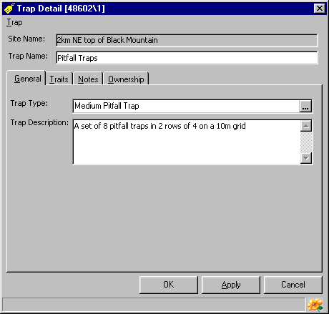
The Trap Detail window holds details on a trap.

The General tab
Trap Type: The type of trap involved.
Trap Description: A text description of the trap or its situation.

The Traits and Notes tabs
For information on notes and traits see Entering Traits and Notes above.

The Ownership tab
This page contains information on the person who created the current record as well as the person who most recently modified it. This information is read-only and is maintained by BioLink. The following information is included:
Date Created: The date and time the current record was originally created.
Created By: The logon name of the person creating the record.
Date last modified: The date and time the record was last updated.
Last modified by: The logon name of the person last updating the record.

Trap Detail window commands

Trap menu
Save/Apply: This command saves changes made in the Detail window. It is equivalent to pressing the Apply button near the bottom of the window. If the window is closed without first saving changes, changes will be lost.
Close: Selecting the Close command will close the window without saving unsaved changes.

Automatically adding information to new records
Templates are predefined sets of data that can be used when adding new records to a database. They are created by entering information in Site Detail, Site Visit Detail and Material Detail windows, and saving these as templates. Once created, these templates can be used to automatically fill new records with the saved information. Using templates will save time by automatically entering commonly used information and will increase data quality by reducing typing errors and forgotten details.
To create a new template open the Site Explorer, select the Create Template command from the Edit menu and choosing the Site, Site Visit or Material command. This will add a new item, named ‘<New Template>‘, to the lower section of the Explorer under Templates. The default name ‘<New Template>‘ should be replaced with an appropriate descriptive name and the Enter key pressed followed by the Apply button to save the new template. To add information to the template, find the template in the Explorer and select the Edit command from the Edit menu. This will open a Detail window for the template. Fill in as many fields as required and press the OK button to save the template with its new data values. This template can then be used when adding new records to prefill fields with the entered information.
To use a template with the Rapid Data Entry window, open the window and select the New Items Use Template Data command from the AutoFill command of the Edit menu. To specify the template to use, select the Set Site Template, Set Site Visit Template or Set Material Template command from the AutoFill command of the Edit menu, select the required template from the list and press the OK button. This will fill the current record in the Rapid Data Entry window with information from the selected template, and all new records added during this session will also contain the information from the Template. Note that it is possible to use the Set Site Template, Set Site Visit Template and Set Material Template commands together to fill information from up to three templates at the same time. To turn off the Autofill feature select the No AutoFill command from the AutoFill menu.
To use templates with the Detail windows, open the Site Explorer, select the parent of the item to be added (a region for a new site, a site for a new site visit and a site visit for a new material record), click the right mouse button or open the Edit menu and select the Add command. Select the type of item to add (Site, Site Visit or Material) from the submenu and then select the From Template command. Select the required template from the list and press the OK button. This will open the appropriate Detail window and automatically fill it with information from the template. Note that the name of the selected template is added to the menu with the From Template command so that in future this template can be selected directly without having to choose it from the list. The template will remain on the menu until another template is selected or the Site Explorer is closed.

Rapid Data Entry’s Copy Current Data command
When working with the Rapid Data Entry window it is possible to enter information in the first record of a series and automatically use this same information in all subsequently created records. To do this, open the Rapid Data Entry window and enter the information to be repeated. When entered, select the New Items Copy Current Data command from the AutoFill command of the Edit menu. Once activated, all new records created during this session of the Rapid Data Entry window will contain the information entered in this first window. This information can be edited as required without effecting the information set with the New Items Copy Current Data command. To change the information automatically entered, cancel this command by selecting No AutoFill from the AutoFill command and then reselect the New Items Copy Current Data command. To turn off the AutoFill feature select the No AutoFill command.
This method of data entry differs from the use of templates in that templates are stored permanently in the database and can be used any number of times. In contrast, Copy Current Data is available only during a single session of the Rapid Data Entry window and information will be lost when the window is closed. If the same information is to be entered for a large number of records then a template(s) should be used, However, if the information being copied relates to only the records currently being entered, then Copy Current Data may be more appropriate.

Material Reports

Taxa for Sites Report
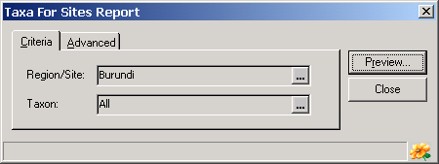
The Taxa for Sites Report provides a text-based report of the taxa for which specimens are held from the specified region or site. The report list the taxa found in the region or at the site, with or without specific collection localities.
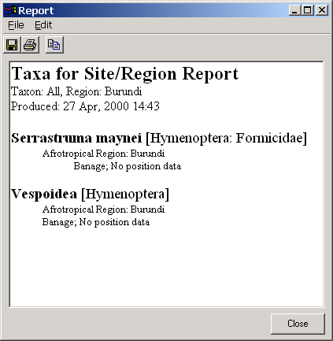
When run, this report opens a dialog box listing the currently selected region, (optionally) a taxon name and a checkbox to hide the locality details. To change the region or taxon name, press the ellipsis button (with the three dots) to the right of the Region/Site or Taxon box. This will open the appropriate Explorer where the region or taxon name can be located and transferred to the dialog box using the Explorer’s Select button or drag and drop. If Hide Localities is checked then only taxon names are included in the report. Once these items are properly set, press the Preview button. This will open a window displaying the taxa known from the selected region.
Information in the report can be copied to the clipboard by selecting the text to be copied and pressing Ctrl+C or using the Copy command from the Edit menu. The entire report can be saved to disk (in RTF: rich text format) by pressing the first toolbar button or selecting the Save As command from the File menu. This will open a Save As dialog box where a file name can be specified. To print the report, press the second toolbar button or select the Print command from the File menu.

Material for Trap Report
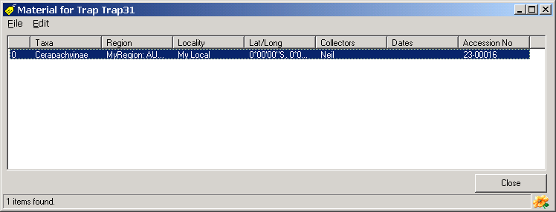
This report provides a detailed list of material for the selected trap. It is especially useful in giving a quick overview of material for a trap and in that the underlying data (Sites, Site Visits, Material and Taxa) can be edited directly from the report. Information in the report is formatted in columns can be quickly reorganised by clicking on the column headings to change the sort order and columns can be reordered using drag and drop.
To edit the underlying information in the report, select a row, open the Edit menu or click the right mouse button and select the Edit Site, Edit Site Visit, Edit Material or Edit Taxon command. This will open a Details window with information for the selected item. To export information in the report to disk, select the Export Data command from the Edit menu. This will open the Export Options window. Select the required report type and press the Export button. A window will open where options for the selected export format can be specified. The options available will vary with the format selected.

